Before change: min_edge_cost = 10.0

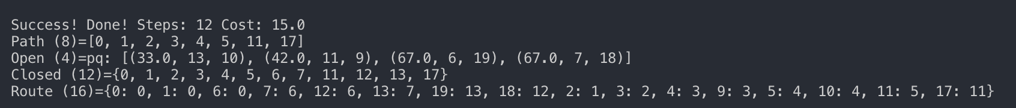

After change:

min_edge_cost = 1.0 *# must be min value for heuristic cost to work*

By changing the value to the min value, more routes are discovered. This means that the path finding algorith is more optimal to find more available solutions.

def reset_navgraph(self):

self.path = None *# invalid so remove if present*

self.graph = SparseGraph()

*# Set a heuristic cost function for the search to use*

self.graph.cost_h = self._manhattan

self.graph.cost_h = self._hypot

self.graph.cost_h = self._max

nx, ny = self.nx, self.ny

*# add all the nodes required*

for i, box in enumerate(self.boxes):

box.pos = (i % nx, i // nx) *#tuple position*

box.node = self.graph.add_node(Node(idx=i))

*# build all the edges required for this world*

for i, box in enumerate(self.boxes):

*# four sided N-S-E-W connections*

if box.kind in no_edge:

continue

*# UP (i + nx)*

if (i+nx) < len(self.boxes):

self._add_edge(i, i+nx)

*# DOWN (i - nx)*

if (i-nx) >= 0:

self._add_edge(i, i-nx)

*# RIGHT (i + 1)*

if (i%nx + 1) < nx:

self._add_edge(i, i+1)

*# LEFT (i - 1)*

if (i%nx - 1) >= 0:

self._add_edge(i, i-1)

*# # Diagonal connections*

*# UP LEFT(i + nx - 1)*

j = i + nx

if (j-1) < len(self.boxes) and (j%nx - 1) >= 0:

self._add_edge(i, j-1, 1.4142) *# sqrt(1+1)*

*# UP RIGHT (i + nx + 1)*

j = i + nx

if (j+1) < len(self.boxes) and (j%nx + 1) < nx:

self._add_edge(i, j+1, 1.4142)

*# DOWN LEFT(i - nx - 1)*

j = i - nx

if (j-1) >= 0 and (j%nx - 1) >= 0:

print( i, j, j%nx)

self._add_edge(i, j-1, 1.4142)

*# DOWN RIGHT (i - nx + 1)*

j = i - nx

if (j+1) >= 0 and (j%nx +1) < nx:

self._add_edge(i, j+1, 1.4142)

Code needed to add diagonal edges is uncommented and fixed.

The use of Manhattan distance calculation is altered.